NODE JS PRACTICAL

# Practical 1

**AIM: Write a Program to pass a message “Hello Node JS” using Node JS Line of Code:**

console.log("Hello Node JS");

**Output Screen:**

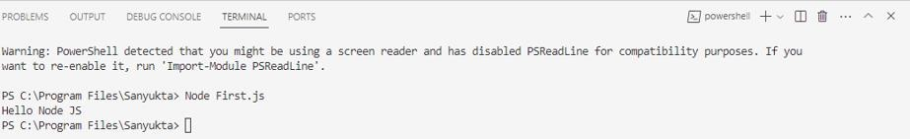

**Practical 2 AIM: Write a program to demonstrate Node.js Functions** **Line Of Code:**

function multiply(x,y){ return x*y;}

let result=multiply(25,78); console.log(result);

**Output Screen:**

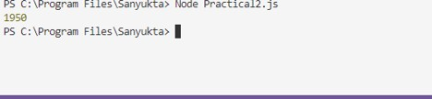

# Practical 3

**AIM: Write a program to demonstrate Call-back function -Anonymous function using Node JS.** **Line Of Code:**

const message=function()

console..log("Welcome to node js");}

setTimeout(message,10000); setTimeout(()=>{

console.log("And now we are staring it");

},3000);

**Output Screen:**

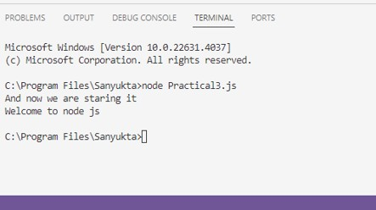

# Practical 4

**AIM: Write a program to demonstrate Node.js Modules.** **Line Of Code:**

exports.myDateFun = function() { return new Date();

};

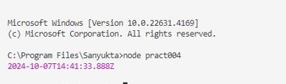const dt = require('./practical4'); console.log(dt.myDateFun()); **Output Screen:**

# Practical 5

**AIM: Write a program to demonstrate routing through hrrp server.** **Line Of Code:**

var http = require('http');

var server = http.createServer(function (req, res) { if (req.url == '/') {

res.writeHead(200, { 'Content-Type': 'text/html' }); res.write("<h1>Home Page</h1>");

res.end();

} else if (req.url == '/student') {

res.writeHead(200, { 'Content-Type': 'text/html' }); res.write("<h1>Master Of Computer Applications</h1>"); res.end();

} else if (req.url == '/admin') {

res.writeHead(200, { 'Content-Type': 'text/html' });

res.write("<h1>Your fee structure will be displayed on the Notice Board.</h1>"); res.end();

} else {

res.writeHead(404, { 'Content-Type': 'text/html' }); res.write("<h1>Invalid page</h1>");

res.end();

}});

**Output Screen:**

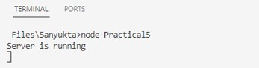

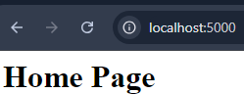

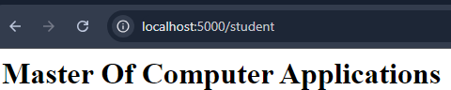

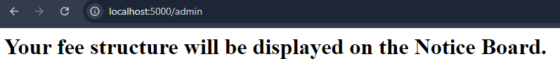

# Practical 6

**AIM: Write a program to demonstrate various Nodel.js Events**

**Line Of Code**:

const events= require("events");

const eventEmitter= new events.EventEmitter(); function listner1(){

console.log("Event received by Listner 1");

}

function listner2(){

console.log("Event received by listner 2");

eventEmitter.addListener("write",listner1); eventEmitter.on("write",listner2);

}

console.log(eventEmitter.listenerCount("write"));

eventEmitter.removeListener("write",listner1); console.log("Listener 1 is removed"); eventEmitter.emit("write");

console.log(eventEmitter.listenerCount("write")); console.log("program ended");

**Output Screen:**

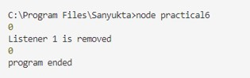

# Practical 7

**AIM: Write a program to demonstrate custom event using Node JS.**

**Line Of Code**:

const events=require('events');

const eventEmitter=new events.EventEmitter(); eventEmitter.on("connection",handleConnectionEvent);

function handleConnectionEvent()

{

console.log("Connection Made !");

}

eventEmitter.emit("connection"); eventEmitter.emit("connection"); eventEmitter.emit("connection"); eventEmitter.emit("connection");

console.log("End of program");

**Output Screen:**

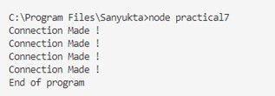

# Practical 8

**AIM: Using File Handling demonstrate all basic file operations (Create, Write, Read , Delete)**

**Line Of Code:**

**Program 1-Read**

var fs=require('fs');

fs.readFile('write.txt',function(err,data){if(err) throw err; console.log(data.toString());

});

**Output Screen:**

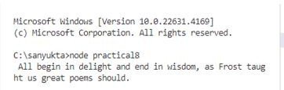

**Program 2- Write Line Of code:**

var fs=require('fs');

fs.writeFile('file.txt','Hi welcome to the txt file',function(err){ if(err) throw err; else{

console.log("Department of Master Of computer Apllication");

}

});

**Output Screen:**

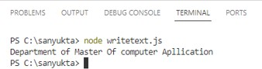

# Program 3-Delete

const fs=require('fs');

fs.unlink('textdelete.txt',function()

{

console.log('Delete Operation Completed');

});

**Output Screen: Before**

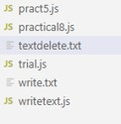

**After Delete**

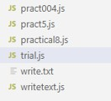

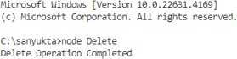

**Practical 9**

**Aim: Create an application to establish a connection with the MySQL database and perform basic database operations on it.**

**Line of code:**

1. **connection_mysql.js**

var mysql = require('mysql');

var con = mysql.createConnection({ host: "localhost", user:"root",

password:""

});

con.connect(function(err){ if (err) throw err;

console.log("Connected!");

});

**Output Screen:**



1. **create_database**

var mysql = require('mysql');

var con = mysql.createConnection({ host: "localhost", user:"root",

password:""

});

con.connect(function(err){ if (err) throw err;

console.log("Connected!");

con.query("CREATE DATABASE Tigerdb", function (err,result){ if (err) throw err;

console.log("Databse created");

});

});

**Output Screen:**



1. **CREATE TABLE**

var mysql = require('mysql');

var con = mysql.createConnection({ host: "localhost", user:"root",

password:"", database: "Tigerdb"

});

con.connect(function(err){ if (err) throw err;

console.log("Connected!");

var sql="CREATE TABLE customers (id INT AUTO_INCREMENT PRIMARY KEY,name VARCHAR(255),address VARCHAR(255))";

con.query(sql, function(err,result){ if (err) throw err; console.log("Table created");

});

});

**Output Screen:**



1. **INSERT RECORD**

var mysql = require('mysql');

var con = mysql.createConnection({ host: "localhost", user:"root",

password:"", database:"Tigerdb"

});

con.connect(function(err){ if (err) throw err;

console.log("Connected!");

var sql="INSERT INTO customers(name, address) VALUES ('TOM','BOISAR'),('HARRY','PALGHAR'),('ORY','VIRAR'),('JERRY','VASAI'),('TOMMY','BOISAR') ";

con.query(sql, function(err,result){ if (err) throw err;

console.log("5 RECORED INSERTED");

});

});

**Output Screen:**



1. **SELECTING RECORD**

var mysql = require('mysql');

var con = mysql.createConnection({ host: "localhost", user:"root",

password:"", database: "Tigerdb"

});

con.connect(function(err){ if (err) throw err;

con.query("SELECT * FROM customers", function(err,result, fields){ if (err) throw err;

console.log(result);

});

});

**Output Screen:**

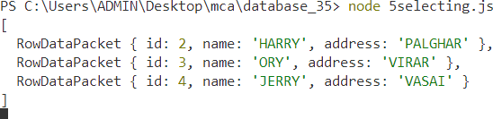

1. **UPDATING RECORD**

var mysql = require('mysql');

var con = mysql.createConnection({ host: "localhost", user:"root",

password:"", database: "Tigerdb"

});

con.connect(function(err){ if (err) throw err;

var sql="UPDATE customers SET address = 'MUMBAI' WHERE address = 'BOISAR'"; con.query(sql, function(err,result){

if (err) throw err;

console.log(result.affectedRows + "record(s) updated");

});

});

**Output Screen:**



**6.DELETING RECORD**

var mysql = require('mysql');

var con = mysql.createConnection({ host: "localhost", user:"root",

password:"", database: "Tigerdb"

});

con.connect(function(err){ if (err) throw err;

var sql="DELETE FROM customers WHERE address = 'MUMBAI'"; con.query(sql, function(err,result){

if (err) throw err;

console.log("Number of records deleted: "+ result.affectedRows);

});

});

**Output Screen:**



# Practical 10

**Aim:Created the application with react js to implement the component lifecycle**

# Source code:

import React, { Component } from 'react'; // Import React and Component import './App.css'; // Import your CSS file

class LifeCycleDemo extends Component { constructor(props) {

super(props);

this.state = { counter: 0 }; console.log('Constructor: Initializing state');

}

componentDidMount() {

console.log('Component Did Mount: Component has been mounted in the DOM');

}

componentDidUpdate(prevProps, prevState) { if (prevState.counter !== this.state.counter) {

console.log('Component Did Update: State has changed, re-rendered');

}

}

componentWillUnmount() {

console.log('Component Will Unmount: Component is about to be removed');

}

increaseCounter = () => {

this.setState({ counter: this.state.counter + 1 });

};

render() {

console.log('Render: Rendering the component'); return (

<div>

<h1>React Component Life Cycle</h1>

<p>Counter: {this.state.counter}</p>

<button onClick={this.increaseCounter}>Increase Counter</button>

</div>

);}}

export default LifeCycleDemo;

**output**

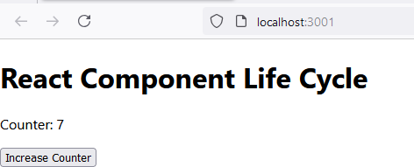

**Practical 11**

**Aim**: **Create an application to implement class and functional components in ReactJS.**

**Source code:**

**Step 1**: **Setting Up the React App**

1. Create React App:

npx create-react-app react-component-demo cd react-component-demo

npm start

# Step 2: Creating Class and Functional Components

We'll create two separate components, one using the class syntax and one using functional syntax.

# Class Component

**In src/ClassComponent.js, create a class component:**

import React, { Component } from 'react';

class ClassComponent extends Component { constructor(props) {

super(props); this.state = {

message: 'Hello from Class Component!',

};

}

render() { return (

<div style={{ border: '2px solid blue', padding: '20px', margin: '10px'

}}> <h2>{this.state.message}</h2>

<p>This is rendered using a class component.</p>

</div>

);

}

}

export default ClassComponent;

# Functional Component

**In src/FunctionalComponent.js, create a functional component:**

import React, { useState } from 'react'; function FunctionalComponent() {

const [message] = useState('Hello from Functional Component!'); return (

<div style={{ border: '2px solid green', padding: '20px', margin: '10px'

}}> <h2>{message}</h2>

<p>This is rendered using a functional component.</p> </div>

);

}

export default FunctionalComponent;

# : Do this changes in App,js

function App() { return (

<div className="App">

<ClassComponent/>

<FunctionalComponent/>

</div>

);

}

**Output:**

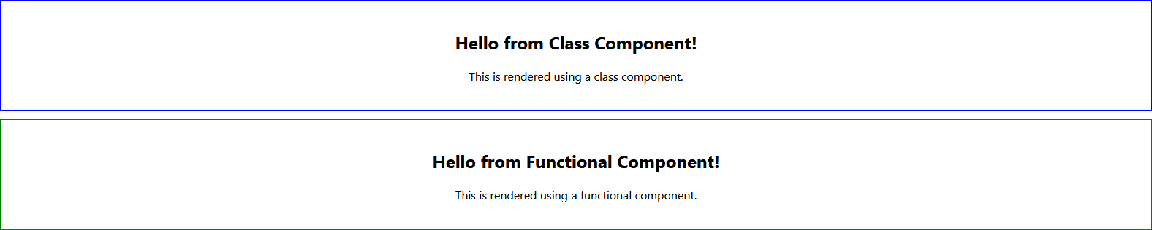

# Practical 12

**Aim**: **Create an application in ReactJS to import and export components.Source code:**

**Step 1: Setting Up the React App**

**npx create-react-app react-import-export-demo cd react-import-export-demo**

**npm start**

**Step 2: Create Multiple Components**

**We'll create three components, each in separate files, and import them into the main App.js file.\**

* 1. **Header Component Header.js**

import React from 'react'; function Header() { return (

<header style={{ backgroundColor: '#4CAF50', color: 'white', padding: '10px' }}>

<h1>Welcome to React Import and Export Demo</h1>

</header>

);

}

export default Header;

* 1. **Footer Component Footer.js**

import React from 'react'; function Footer() { return (

<footer style={{ backgroundColor: '#333', color: 'white', padding: '10px', position: 'fixed', bottom: 0, width: '100%' }}>

<p>React Import and Export Demo © 2024</p>

</footer>

);

}

export default Footer;

* 1. **MainContent Component MainComponent.js**

import React from 'react';

import Header from './Header'; // Importing Header component

import MainContent from './MainContent'; // Importing MainContent component import Footer from './Footer'; // Importing Footer component

function App() { return (

<div>

<Header />

<MainContent />

<Footer />

</div>

);

}

export default App;

**Step 3: Import Components into App**

import React from 'react';

import Header from './Header'; // Importing Header component

import MainContent from './MainContent'; // Importing MainContent component import Footer from './Footer'; // Importing Footer component

function App() { return (

<div>

<Header />

<MainContent />

<Footer />

</div>

);

}

export default App;

**Output:**

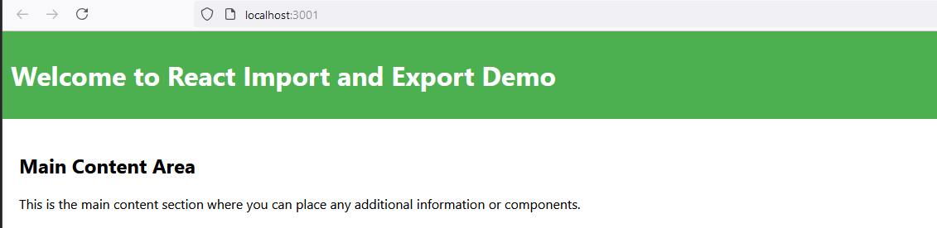

# Practical 13

**Aim: Create an application to implement state and props in ReactJS.**

**Source code:**

**Step 1: Setting Up the React App**

**npx create-react-app react-state-props-demo cd react-state-props-demo**

**npm start**

* 1. **Parent Component**

; import React, { useState } from 'react';

import ChildComponent from './ChildComponent'; function ParentComponent() {

// Define state

const [message, setMessage] = useState('Hello from Parent!'); const updateMessage = () => {

setMessage('I LOVE PANIPURI!!');

};

return (

<div style={{ border: '2px solid blue', padding: '20px', margin: '10px' }}> <h2>Parent Component</h2>

<p>Message in Parent: {message}</p>

{/* Passing message and function as props to ChildComponent */} <ChildComponent message={message} updateMessage={updateMessage} /> </div>

);

}

export default ParentComponent;

**Step 3: Create a Child Component**

import React from 'react';

function ChildComponent({ message, updateMessage }) { return (

<div style={{ border: '2px solid green', padding: '20px', margin: '10px' }}>

<h2>Child Component</h2>

<p>Message from Parent: {message}</p>

<button onClick={updateMessage}>CLICK HERE FOR MORE INFO</button>

</div>

);

}

export default ChildComponent;

* 1. **Update App.js**

Open src/App.js and modify it as follows: import React from 'react';

import ParentComponent from './ParentComponent'; function App() {

return (

<div className="App">

<h1>React State and Props Demo</h1>

<ParentComponent />

</div>

);

}

export default App;

**Output:**

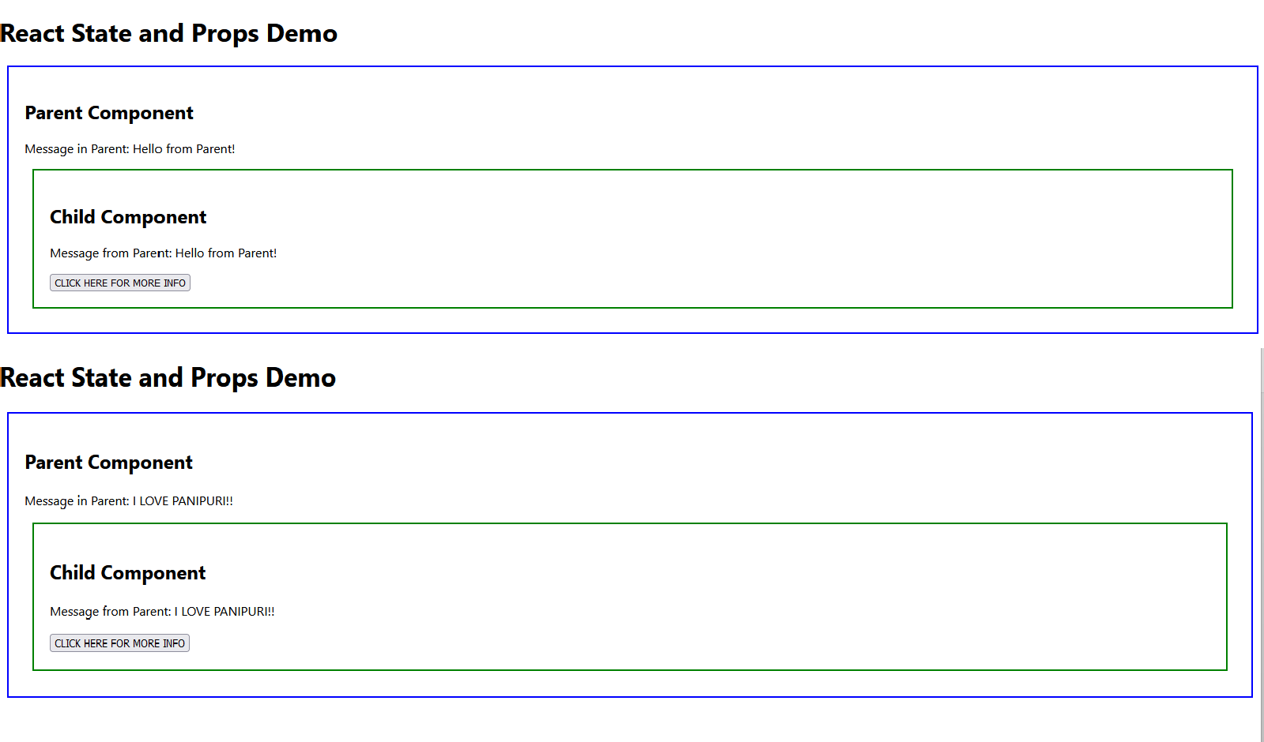

# Practical 14

**Aim: Create an application in ReactJS to use DOM events. Source code:**

**Step 1: Setting Up the React App**

**npx create-react-app react-dom-events-demo cd react-dom-events-demo**

**npm start**

**Step 2: Handling Different DOM Events**

**2.1 Create a DOMEventsComponent DOMEventsComponent.js**

import React, { useState } from 'react';

function DOMEventsComponent() {

const [inputValue, setInputValue] = useState(''); const [hovered, setHovered] = useState(false);

// Handle button click

const handleClick = () => { alert('Button clicked!');

};

// Handle input change

const handleChange = (event) => { setInputValue(event.target.value);

};

// Handle mouse hover

const handleMouseOver = () => { setHovered(true);

};

const handleMouseOut = () => { setHovered(false);

};

return (

<div style={{ padding: '20px', textAlign: 'center' }}>

<h2>React DOM Events Demo</h2>

{/* onClick Event */}

<button onClick={handleClick} style={{ padding: '10px', fontSize: '16px'

}}> Click Me

</button>

{/* onChange Event */}

<div style={{ margin: '20px 0' }}>

<input type="text"

placeholder="Type something..." value={inputValue} onChange={handleChange}

style={{ padding: '10px', fontSize: '16px' }}

/>

<p>You typed: {inputValue}</p>

</div>

{/* onMouseOver Event */}

<div onMouseOver={handleMouseOver} onMouseOut={handleMouseOut} style={{

backgroundColor: hovered ? 'lightblue' : 'lightgray', padding: '20px',

cursor: 'pointer',

}}

>

{hovered ? 'Mouse is Over' : 'Hover over this box'}

</div>

</div>

);

}

export default DOMEventsComponent;

**Step 3: Modify App Component**

**3.1 Update App.js**

**Open src/App.js and modify it as follows:**

import React from 'react';

import DOMEventsComponent from './DOMEventsComponent';

function App() { return (

<div className="App">

<h1>React DOM Events Example</h1>

<DOMEventsComponent />

</div>

);

}

export default App;



**Ouput:**

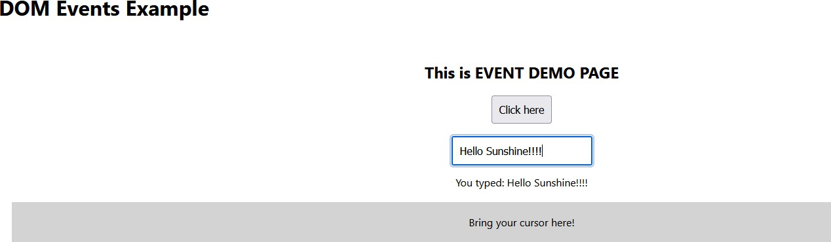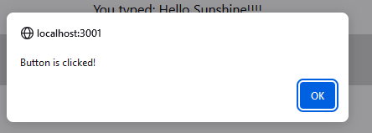

# Practical 15

**Aim: Create an application in ReactJS form and add client and server- side validation.**

**Source code:**

**Step 1: Setting Up the React App**

**npx create-react-app react-form-validation-demo cd react-form-validation-demo**

**npm start**

**Step 2: Create the Form Component**

**2.1 Create a RegistrationForm.js**

import React, { useState } from 'react'; function RegistrationForm() {

const [formData, setFormData] = useState({

name: '',

email: '', password: ''

});

const [formErrors, setFormErrors] = useState({}); const [isSubmitted, setIsSubmitted] = useState(false);

// Handle form input changes const handleChange = (e) => { const { name, value } = e.target; setFormData({

...formData, [name]: value

});

};

// Validate form data const validate = () => { let errors = {};

if (!formData.name) errors.name = 'Name is required'; if (!formData.email) {

errors.email = 'Email is required';

} else if (!/\S+@\S+\.\S+/.test(formData.email)) { errors.email = 'Email address is invalid';

}

if (!formData.password) { errors.password = 'Password is required';

} else if (formData.password.length < 6) {

errors.password = 'Password must be at least 6 characters'; } return errors;

};

// Handle form submission const handleSubmit = (e) => { e.preventDefault();

const errors = validate(); setFormErrors(errors);

if (Object.keys(errors).length === 0) {

// Mock server request setIsSubmitted(true);

console.log('Form data submitted:', formData);

// In real implementation, send data to the server here

} else { setIsSubmitted(false);

}

};

return (

<div className="form-container" style={{ textAlign: 'left', padding: '20px'

}}> <h2>Registration Form</h2>

{isSubmitted && <p style={{ color: 'green' }}>Form submitted successfully!</p>}

<form onSubmit={handleSubmit}>

<div>

<label>Name:</label>

<input type="text" name="name"

value={formData.name} onChange={handleChange}

style={{ display: 'block', marginBottom: '10px', padding: '5px' }} />

{formErrors.name && <p style={{ color: 'red' }}>{formErrors.name}</p>} </div>

<div>

<label>Email:</label>

<input type="email" name="email"

value={formData.email} onChange={handleChange}

style={{ display: 'block', marginBottom: '10px', padding: '5px' }} />

{formErrors.email && <p style={{ color: 'red' }}>{formErrors.email}</p>} </div>

<div>

<label>Password:</label>

<input type="password" name="password"

value={formData.password} onChange={handleChange}

style={{ display: 'block', marginBottom: '10px', padding: '5px' }} />

{formErrors.password && <p style={{ color: 'red'

}}>{formErrors.password}</p>}

</div>

<button type="submit" style={{ padding: '10px 20px', marginTop: '10px' }}> Submit

</button>

</form>

</div>

);

}

export default RegistrationForm;

**Step 3: Modify App Component**

**3.1 Update App.js**

import React from 'react';

import RegistrationForm from './RegistrationForm'; function App() {

return (

<div className="App">

<h1>React Form with Validation</h1>

<RegistrationForm />

</div>

);

}

export default App;

**Step 4: Running the App npm start**

**Step 5: Adding Server-Side Validation (Optional)**

For server-side validation, we will mock a simple server using an API call. Normally, you would send form data to an actual server to check its validity. You can use a backend framework like Node.js or Django for that. To simulate a server response, we can create a mock API call using fetch or any other HTTP client.

**5.1 Mock Server Validation**

Modify the handleSubmit function to mock a server request:

// Handle form submission with mock server request const handleSubmit = async (e) => { e.preventDefault();

const errors = validate();

setFormErrors(errors);

if (Object.keys(errors).length === 0) { try {

const response = await fetch('https://jsonplaceholder.typicode.com/posts', { method: 'POST',

body: JSON.stringify(formData), headers: {

'Content-type': 'application/json; charset=UTF-8',

},

});

if (response.ok) { setIsSubmitted(true);

console.log('Form data sent to the server:', formData);

}

} catch (error) {

console.error('Server validation failed', error);

}

} else { setIsSubmitted(false);

}

};

**Output:**

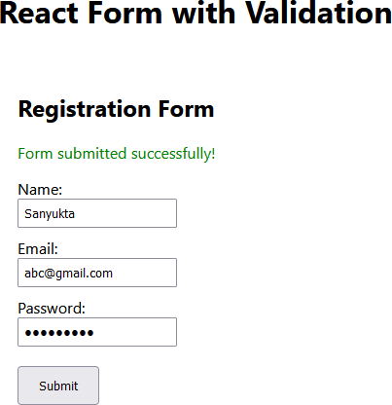

# Practical 16

**Aim: Create an application in ReactJS that uses routing for navigation.. Source code:**

**Step 1: Setting Up the React App**

**npx create-react-app react-routing-demo cd react-routing-demo**

**npm install react-router-dom npm start**

**Step 2: Setting Up React Router**

**2.1 Create the Components Home.js**

import React from 'react';

function Home() { return (

<div style={{ textAlign: 'center', padding: '20px' }}>

<h2>Welcome to the Home Page</h2>

<p>This is the main page of our application.</p>

</div>

);

}

export default Home;

**About.js**

import React from 'react'; function About() {

return (

<div style={{ textAlign: 'center', padding: '20px' }}>

<h2>About Us</h2>

<p>This is the about page where we describe our app.</p> </div>

);

}

export default About;

**Contact.js**

import React from 'react';

function Contact() { return (

<div style={{ textAlign: 'center', padding: '20px' }}>

<h2>Contact Us</h2>

<p>This is the contact page for inquiries.</p>

</div>

);

}

export default Contact;

**Step 3: Setting Up the Router**

**3.1 Update App.js**

import React from 'react';

import { BrowserRouter as Router, Route, Routes, Link } from 'react-router-dom'; import Home from './Home';

import About from './About'; import Contact from './Contact'; function App() {

return (

<Router>

<div style={{ textAlign: 'center', padding: '20px' }}>

<h1>React Routing Demo</h1>

{/* Navigation Links */}

<nav style={{ marginBottom: '20px' }}>

<Link to="/" style={{ margin: '0 15px' }}>Home</Link> <Link to="/about" style={{ margin: '0 15px' }}>About</Link> <Link to="/contact" style={{ margin: '0 15px' }}>Contact</Link> </nav>

{/* Route Definitions */}

<Routes>

<Route path="/" element={<Home />} />

<Route path="/about" element={<About />} />

<Route path="/contact" element={<Contact />} />

</Routes>

</div>

</Router>

);

}

export default App;

**Output:**

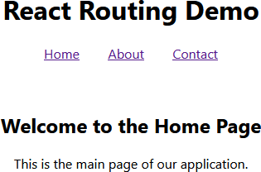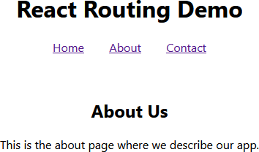

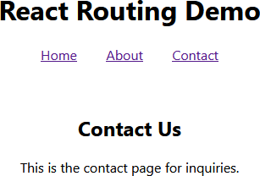

# Practical 17

**Aim: Create a simple ReactJS application with Hooks (useState, useEffect, useContext). Source Code:**

**Counter.js**

import React, { useState } from 'react'; function Counter() {

const [count, setCount] = useState(0); return (

<div style={{ textAlign: 'center', padding: '20px' }}>

<h2>Counter</h2>

<p>Current Count: {count}</p>

<button onClick={() => setCount(count + 1)}>Increase</button>

<button onClick={() => setCount(count - 1)} style={{ marginLeft: '10px'

}}>Decrease</button>

</div>

);

}

export default Counter;

**DataFetching.js**

import React, { useState, useEffect } from 'react'; function DataFetching() {

const [data, setData] = useState([]);

const [loading, setLoading] = useState(true); useEffect(() => { fetch('https://jsonplaceholder.typicode.com/posts')

.then((response) => response.json())

.then((data) => {

setData(data.slice(0, 5)); // Displaying only the first 5 items setLoading(false);

})

.catch((error) => console.error(error));

}, []); // Empty array ensures this runs once on mount return (

<div style={{ textAlign: 'center', padding: '20px' }}>

<h2>Data Fetching</h2>

{loading ? (

<p>Loading...</p>

) : (

<ul>

{data.map((item) => (

<li key={item.id}>{item.title}</li>

))}

</ul>

)}

</div>

);

}

export default DataFetching;

**ThemeContext.js**

import React, { createContext, useState } from 'react'; export const ThemeContext = createContext();

export const ThemeProvider = ({ children }) => {

const [isDarkTheme, setIsDarkTheme] = useState(false); const toggleTheme = () => { setIsDarkTheme((prevTheme) => !prevTheme);

};return (

<ThemeContext.Provider value={{ isDarkTheme, toggleTheme }}>

{children}

</ThemeContext.Provider>

);

};

**ThemedComponent.js**

import React, { useContext } from 'react';

import { ThemeContext } from './ThemeContext'; function ThemedComponent() {

const { isDarkTheme, toggleTheme } = useContext(ThemeContext); return (

<div>style={{ textAlign: 'center', padding: '20px',

backgroundColor: isDarkTheme ? '#333' : '#fff', color: isDarkTheme ? '#fff' : '#000',

}}

>

<h2>Theme Toggle</h2>

<p>Current Theme: {isDarkTheme ? 'Dark' : 'Light'}</p>

<button onClick={toggleTheme}>Toggle Theme</button>

</div>);

}

export default ThemedComponent;

**App.js**

import React from 'react'; import Counter from './Counter';

import DataFetching from './DataFetching';

import ThemedComponent from './ThemedComponent'; import { ThemeProvider } from './ThemeContext'; function App() {

return (

<ThemeProvider>

<div className="App" style={{ textAlign: 'center', padding: '20px' }}>

<h1>React Hooks Demo</h1>

<Counter />

<DataFetching />

<ThemedComponent />

</div>

</ThemeProvider>

);}

export default App;

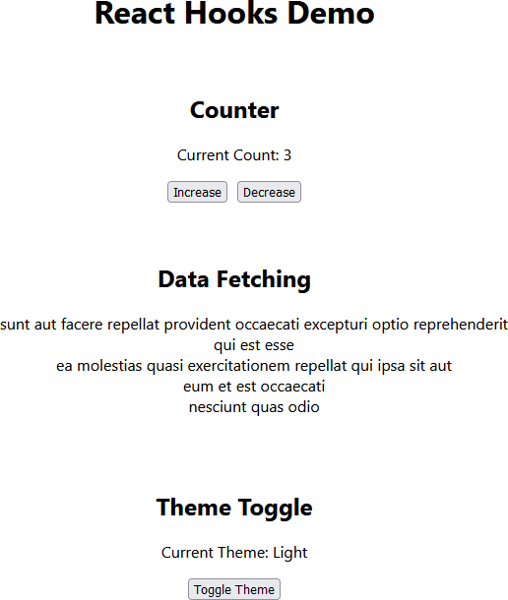**Output:**